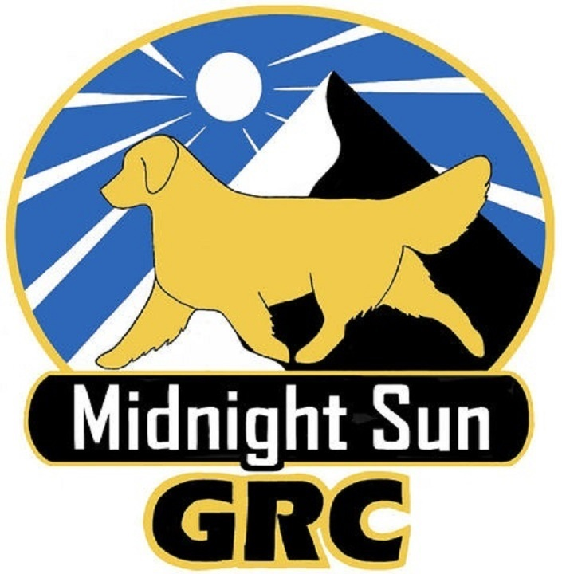
Midnight Sun Golden Retriever Club
2024 Membership Renewal Form

NAME:

ADDRESS:

CITY: STATE: ZIP:

HOME PHONE: ALTERNATE PHONE:

E-mail:

Website:

TYPE OF MEMBERSHIP RENEWAL:

____Supporting - $100 – Members at any level who elect to pay $100 annual dues are recognized as a “Supporting Member” with a double asterisk beside their name whenever membership lists are published or distributed. Becoming a Supporting Member shall be an option on an annual basis and provide the benefits of a Regular Membership.

____Regular Individual - $25 - Open to all persons eighteen years of age and older who are in good standing with The American Kennel Club. While the membership is to be unrestricted as to residence, the Club’s primary purpose is to be representative of the breeders and exhibitors in its immediate area. Each applicant for regular membership shall have attended two Club sponsored functions, one of which must be a club meeting where the applicant is introduced to the general membership. Regular Individual Members are entitled to one vote and may hold office.

____ Regular Family - $40 - People living at the same address. Family Membership is limited to two adults (18 years or older) per household. Family Membership is entitled to a maximum of two votes per household, who both have all the benefits of a Regular Membership.

____ Associate - $20 - Open to all persons eighteen years or age or older and must be in good standing with The American Kennel Club and must have attended at least one Club sponsored function (not necessarily a meeting). Applicants may apply for membership as described in Section 3 of the Bylaws and will be awarded all benefits and responsibilities of membership except voting and being counted towards a quorum.

____ Junior - $20 – Junior Membership is available to persons 14 – 17 years of age. Junior members are not eligible to vote or hold office until the age of 18. At that time, the membership automatically shifts to a Regular membership.

Mail to: Kathleen King
18608 Jude Island Circle
Eagle River, AK 99577

Signature: ____________________________________________________

Checks and renewal form must be postmarked by January 1, 2024

